Model-View-Controller (MVC)
# Source: AI Source: Provided by: [Data Path: Persons Table -> ID Column: 1, Name_En Column: Motasem Essam] -> From: [ChatGPT] on [1/23/2026]
Model-View-Controller (MVC) is an architectural pattern that separates an application into three main components:
- Model → Data and business logic
- View → User interface (UI)
- Controller → Handles input and coordinates between Model and View
👉 Think of it like a restaurant:
- Model = Kitchen (data & logic)
- View = Menu / Table (what user sees)
- Controller = Waiter (handles requests)

🔑 Key Idea
# Source: AI Source: Provided by: [Data Path: Persons Table -> ID Column: 1, Name_En Column: Motasem Essam] -> From: [ChatGPT] on [1/23/2026]
Separate data, UI, and control logic to make code clean and maintainable

🧱 Structure
# Source: AI Source: Provided by: [Data Path: Persons Table -> ID Column: 1, Name_En Column: Motasem Essam] -> From: [ChatGPT] on [1/23/2026]
User → Controller → Model → Controller → View → User
- User interacts with Controller
- Controller updates the Model
- Model provides data to the View
- View displays results to the user

🧩 Example

Model
# Source: AI Source: Provided by: [Data Path: Persons Table -> ID Column: 1, Name_En Column: Motasem Essam] -> From: [ChatGPT] on [1/23/2026]
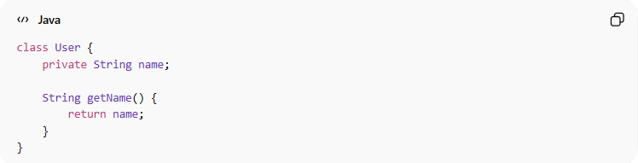
class User {
private String name;

String getName() {
return name;
}
}

View
# Source: AI Source: Provided by: [Data Path: Persons Table -> ID Column: 1, Name_En Column: Motasem Essam] -> From: [ChatGPT] on [1/23/2026]
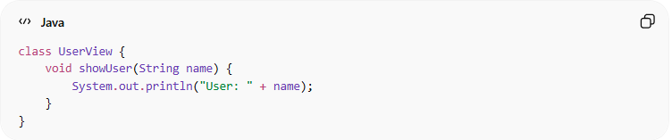
class UserView {
void showUser(String name) {
System.out.println("User: " + name);
}
}

Controller
# Source: AI Source: Provided by: [Data Path: Persons Table -> ID Column: 1, Name_En Column: Motasem Essam] -> From: [ChatGPT] on [1/23/2026]
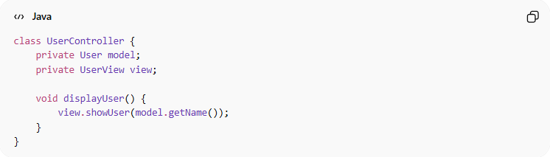
class UserController {
private User model;
private UserView view;

void displayUser() {
view.showUser(model.getName());
}
}

❌ Bad Example (Without MVC)
# Source: AI Source: Provided by: [Data Path: Persons Table -> ID Column: 1, Name_En Column: Motasem Essam] -> From: [ChatGPT] on [1/23/2026]
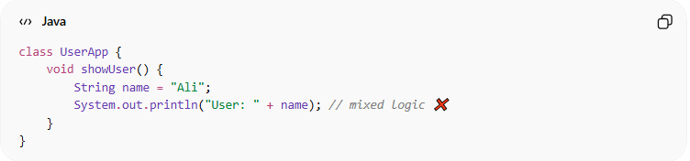
class UserApp {
void showUser() {
String name = "Ali";
System.out.println("User: " + name); // mixed logic ❌
}
}
👉 Problems:
- UI and data mixed together
- Hard to maintain and test

✅ Benefits
# Source: AI Source: Provided by: [Data Path: Persons Table -> ID Column: 1, Name_En Column: Motasem Essam] -> From: [ChatGPT] on [1/23/2026]
- Clear separation of concerns
- Easier testing (each part independently)
- UI can change without affecting business logic
- Improves maintainability

⚠️ Drawbacks
# Source: AI Source: Provided by: [Data Path: Persons Table -> ID Column: 1, Name_En Column: Motasem Essam] -> From: [ChatGPT] on [1/23/2026]
- More files and structure (can feel complex for small apps)
- Requires discipline to keep separation clean

⚡ When to Use
# Source: AI Source: Provided by: [Data Path: Persons Table -> ID Column: 1, Name_En Column: Motasem Essam] -> From: [ChatGPT] on [1/23/2026]
- Web applications (e.g., frameworks like Spring MVC)
- Desktop applications
- Applications with clear UI and business logic separation

💡 Key Idea
# Source: AI Source: Provided by: [Data Path: Persons Table -> ID Column: 1, Name_En Column: Motasem Essam] -> From: [ChatGPT] on [1/23/2026]
MVC helps you build applications where UI changes don’t break business logic and vice versa

🧾 Summary
# Source: AI Source: Provided by: [Data Path: Persons Table -> ID Column: 1, Name_En Column: Motasem Essam] -> From: [ChatGPT] on [1/23/2026]
MVC separates your app into:
- Model → Data
- View → UI
- Controller → Logic handler
👉 Result: clean, organized, and maintainable code

